# *Lab manual 10*

## Name: Muhammad Usman Bhutto.

## Roll no: 453891.

## Section: B.

## *Task 1:*

#include <iostream>

#include <vector>

using namespace std;

int main() {

vector<int> myVector;

myVector.push_back(1);

myVector.push_back(2);

myVector.push_back(3);

myVector.push_back(4);

myVector.push_back(11);

myVector.push_back(6);

myVector.push_back(7);

myVector.push_back(8);

myVector.push_back(9);

myVector.push_back(10);

cout << "Elements in the vector: ";

for (vector<int>::iterator it = myVector.begin(); it != myVector.end(); ++it) {

cout << *it << " ";

}

cout << endl;

myVector.push_back(5);

if (!myVector.empty() && myVector.size() > 2) {

vector<int>::iterator it = myVector.begin() + 2;

myVector.erase(it);

}

cout << "Elements in the vector after pushing 5 and removing element at position 2: ";

for (int element : myVector) {

cout << element << " ";

}

cout << endl;

return 0;

}

## *Output:*

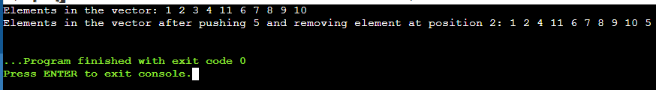

## *Task 2:*

#include <iostream>

#include <vector>

#include <algorithm>

#include <numeric>

using namespace std;

int main() {

int numPairs;

cout << "Enter the number of name/grade pairs: ";

cin >> numPairs;

vector<string> names(numPairs);

vector<int> grades(numPairs);

for (int i = 0; i < numPairs; i++) {

cout << "Enter name " << i + 1 << ": ";

cin >> names[i];

cout << "Enter grade for " << names[i] << ": ";

cin >> grades[i];

}

double mean = accumulate(grades.begin(), grades.end(), 0.0) / numPairs;

cout << "Mean grade: " << mean << endl;

sort(grades.begin(), grades.end());

double median = (numPairs % 2 == 0)

? (grades[numPairs / 2 - 1] + grades[numPairs / 2]) / 2.0

: grades[numPairs / 2];

cout << "Median grade: " << median << endl;

int modeCount = 1, maxModeCount = 1;

int mode = grades[0];

for (int i = 1; i < numPairs; i++) {

if (grades[i] == grades[i - 1]) {

modeCount++;

} else {

modeCount = 1;

}

if (modeCount > maxModeCount) {

maxModeCount = modeCount;

mode = grades[i];

}

}

cout << "Mode grade: " << mode << endl;

cout << "Names with mode grade: ";

for (int i = 0; i < numPairs; i++) {

if (grades[i] == mode) {

cout << names[i] << " ";

}

}

cout << endl;

return 0;

}

## *Output:*

